Energy Efficiency in <insert community>

Energy Tips for
Community Residents

March 2015

Insert Community logo here
Developed by

through support of
the Ministry of Energy and Mines and BC Hydro

Factors Affecting Energy Consumption
Energy efficiency is generally affected by three main factors: the quality of home construction and materials at the beginning, the frequency and extent of good maintenance practices, and how residents use the home and its components. You can have the biggest impact by being aware of how energy works and by using good practices to lower consumption.

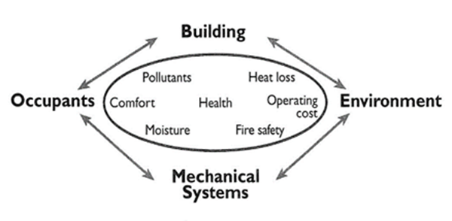

Where Energy Dollars Go
The following breakdown shows where most energy dollars are spent. By far, the largest amount is spent on heating, of both your home and water. If you choose only a few tips to start with from the Tips for Saving Energy lists below, focusing on heating and hot water solutions will have the biggest impact on your bills.

Tips for Saving Energy (and Money!)

Heating
- Set your thermostat as low as comfortable (68°F (20°C) is suggested) when you are at home.
- Set back the thermostat to 60°F (16°C) at night or when no one is at home.
- Set back the thermostat to 50-55°F (12°C) when the house is empty for over 24 hours.
- Install a programmable thermostat to automatically provide these setbacks.
- Close your fireplace damper and make sure the opening is sealed when the fireplace is not being used.
- Regularly clean heating registers and make sure they are not blocked.
- Open blinds and shades on sunny winter days, and close them at night.
- Use door sweeps or door socks to decrease the drafts coming in from the bottom of doors.

<insert appropriate thermometer graphic here from provided options>
LM: Lower Mainland, SI: Southern Interior, or NI: Northern Interior and either Zone 1 or Zone 2 rates

Hot Water
- Turn off dripping taps and fix broken seals that drip when tap is fully closed.
- Wash clothes in cold water, except for special loads such as diapers and stained clothes, and use the appropriate water setting for the load.
- Reduce the temperature setting of your water heater to 120°F / 50°C (medium setting on a gas heater dial), as long as your dishwasher has a booster heater.

Appliances
- Maintain your refrigerator at 35-40°F (3-4°C) and freezer at 0-5°F (-18°C).
- Maintain stand-alone deep freeze at 0°F (-18°C).
- Keep your refrigerator door closed whenever possible.
- Regularly clean under your fridge and remove dust from the coils on the back of your fridge.
- Minimize freezer ice build-up.
- Use microwave ovens for cooking small meals.
- Adjust the flame on gas cooking appliances so it is blue, not yellow.
- Replace older gas cooking appliances with a unit that has an automatic, electric ignition system.
- If you have a newer dishwasher, skip pre-rinsing the dishes.
- Run the dishwasher only with a full load.
- Use the air dry function (instead of heat dry) to dry dishes in your dishwasher.
- Regularly clean the lint filter on your dryer and inspect the dryer vent to make sure it is not blocked.
- Do not overload your dryer as it takes clothes longer to dry.
- Shut down home computers or put them on sleep mode when not in use.
- Plug small electronics into a power strip so you can turn them off at the same time.
- Turn off the TV when no one is viewing it.
- Choose small appliances such as curling irons and coffee pots with time limited shut off switches.
- Replace aging appliances, when needed, with energy efficient Energy Star® models.
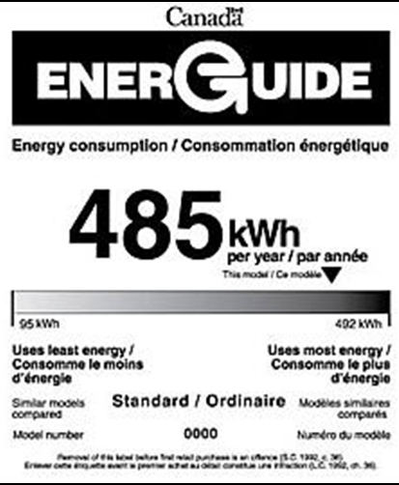
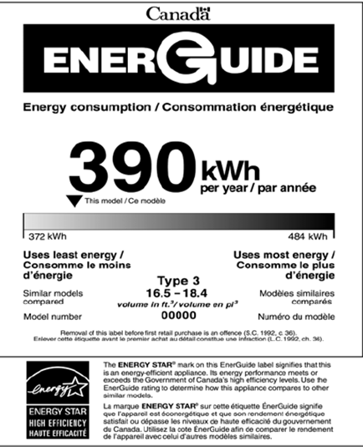
Look for lower kWh ratings and
Energy Star® designation

Lights
- Turn off lights when not in use.
- Use task lighting whenever possible instead of brightly lighting the entire room.
- Choose LED (best) or CFL (good) lightbulbs instead of older incandescent bulbs.
