Energy Efficiency in <insert community>

Recommendations for
Chief and Council

March 2015

Insert Community logo here
Developed by

through support of
the Ministry of Energy and Mines and BC Hydro
These charts and checklists can assist you in structuring, developing, and implementing an energy efficiency program in your community. They are intended to supplement the interactive energy efficiency workshop, which has been tailored to reflect your community’s energy situation.

Factors Affecting Energy Consumption
Energy efficiency is generally affected by three main factors: the quality of home construction and materials at the beginning, the frequency and extent of good maintenance practices, and how residents use the home and its components. Each is important for consideration in developing an energy program, and the extent to which each is applicable may be different depending on your current situation.

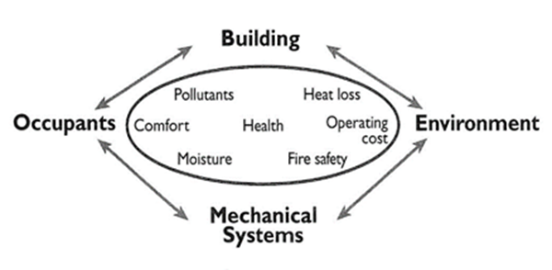

Where Energy Dollars Go
The following breakdown shows where most energy dollars are spent. By far, the largest amount is spent on heating, of both your home and water. Therefore, in developing a priority of actions within your community, you may want to focus initial efforts on improving air sealing, increasing insulation, and upgrading to better heating systems (e.g., installing efficient wood/electric furnaces that capitalize on using wood with the benefit of having backup heat when residents aren’t home).

Policy Development
A holistic Housing Policy, including energy efficiency requirements, represents the ‘tip of the iceberg’ in terms of the larger management and housing structure in a community. The following pyramid highlights a logical series of steps and considerations that can be followed to build a solid foundation for policy development.
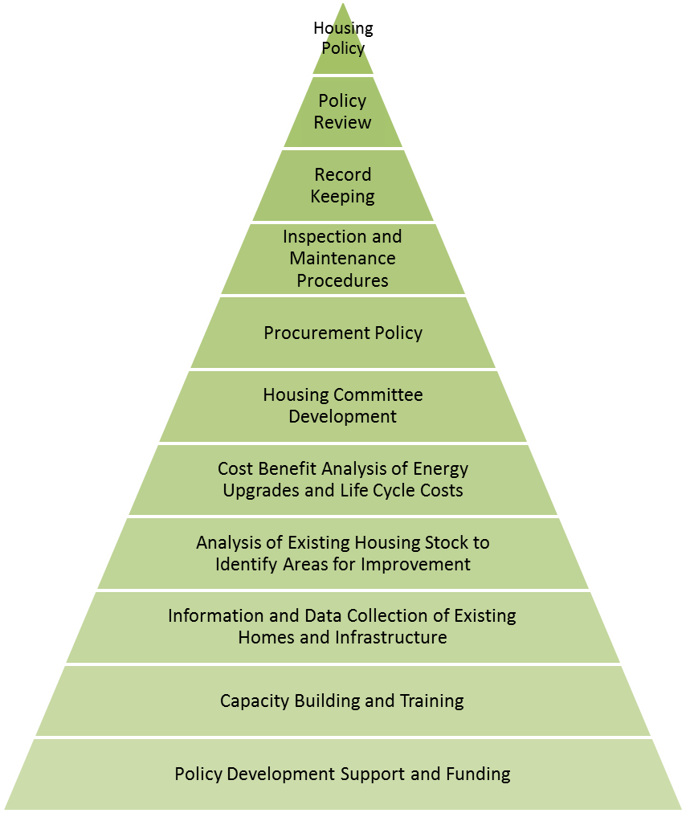
Policy development process

Policy Development Framework
Policy Areas | No EE Policy |  |  |  | Highly Developed  EE Policy
Policy Development and Use | No guidelines around EE | The Band has an unwritten set of guidelines around EE | The Band has an EE policy but the policy has not been formally adopted by the Leadership | The Band has a formal EE policy the policy but no active ongoing commitment from the Leadership | The Band has an EE policy action plan which is regularly reviewed and has active commitment of the Leadership
Organization | No delegation or responsibility for managing energy use by the community | Informal and loose EE requirements with the Band mainly focused on energy supply | There is some delegation of responsibility for EE but management and authority is unclear | There is a clear line for accountability by the Band administration around the overall consumption of energy and responsibility for the efficient use of energy | The EE policy is fully integrated into Band administration structure with clear accountability for the community’s overall energy consumption
Investment | No investment in improving energy efficiency | Only low or medium cost measures are considered; other measures are undertaken only when required by funders | Low or medium cost measures for EE are routinely considered when short payback periods are achievable | Equal appraisal criteria used for energy as for other cost reduction projects | Resources routinely committed to EE in support of Band objectives
Performance Measurement | No measurement or records of energy consumption completed | Check of energy related invoices only | Monthly monitoring by fuel type | Scheduled energy performance measurement for each process, unit or site | Comprehensive energy performance measurement against targets with effective reporting to Leadership and community
Staff Training | Informal EE organization with main focus on ensuring secure energy supply | Technical staff occasionally attend specialist courses | Ad-hoc training for selected staff, as required | Energy training targeted at major users following training needs analysis | Comprehensive staff training tailored to identify EE opportunities and to develop business cases which can be acted upon
Communications | No communications or promotion of EE issues | Ad-hoc informal contacts used to promote EE | Some use of organization communication mechanisms to promote EE | Regular staff briefings, performance reports and EE promotion | Extensive communication of energy issues and impacts within the Band administration and community

Next Steps in Developing an Energy Efficiency Program
Policy Areas | Recommended Actions
Policy development and use | - Gather baseline energy consumption – understand how much residents and the band is spending on energy  - Develop a target for energy savings (e.g., 30% savings relative to current levels)  - Commit to energy efficient buildings for new construction (e.g., new BC Building Code)  - Create an energy efficiency policy which has active commitment of the Leadership
Organization | - Identify responsibility for managing energy use and energy efficiency programs within the administration structure  - Make sure procurement policies reflect a commitment to energy efficiency (e.g., consider lifecycle analysis)
Investment | - Allocate a budget for energy efficiency projects (e.g., 2% of energy expenditures)  - Commit to investing in low cost and no cost activities, such as Energy Star® appliances instead of alternatives
Performance Measurement | - Conduct biannual reporting of energy expenditures and savings from initiatives
Staff Training | - Provide training to administrators on accounting for energy efficiency  - Seek funding for operations and maintenance staff to train in energy efficient housing practices
Communications | - Communicate activities and successes to the community

Framework for Energy Efficiency within Housing Policy

Strategy for <insert community>
Maintenance and Construction Guidelines | Year One | Year Two | Year Three | Year Four | Year Five

Building Construction Standard Comparison
 | Current BC Building Code | Energuide 80 | R-2000 | Energy Star®
Requirements | - Insulation, space and water heating equipment designed and installed in accordance with 9.36 of the BC Building Code | - Use energy efficient windows, heat recovery ventilation or improved insulation to meet energy target  - High efficiency space and water heating appliances | - Heat recovery ventilation required  - Mandatory air tightness levels  - Increased insulation of building enclosure to meet Energuide 80 performance level | - Use Energy Star® windows  - Use Energy Star® appliances  - Heat recovery ventilation required  - Increased insulation of building enclosure above code minimum  - Mandatory air tightness levels  - High efficiency space and water heating appliances
Costs | - Standard | - Additional $8,000 - $12,000 (or higher) per house | - Additional $8000 - $12,000 (or higher) per house | - Additional $10,000 - $15,000 (or higher) per house
Potential Energy Savings | - Baseline | - Varies | - 20% | - 20%
Benefits | - Cost effective house and construction cost | - Reduced operating costs  - Improved indoor air quality  - Reduced noise  - Improved humidity control | - Reduced operating costs  - Improved indoor air quality  - Reduced noise  - Improved humidity control  - Built by certified R2000 contractor | - Reduced operating costs  - Improved indoor air quality  - Reduced noise  - Improved humidity control
Drawbacks | - Unquantified higher operating costs reflecting lower air sealing and other construction standards | - Higher initial cost  - Investment in additional training for maintenance persons on new components | - Higher initial cost  - Investment in additional training for maintenance persons on new components | - Higher initial cost  - Investment in additional training for maintenance persons for new components

