Energy Efficiency in <insert community>

Recommendations for
Maintenance and Operations Staff

March 2015

Insert Community logo here
Developed by

through support of
the Ministry of Energy and Mines and BC Hydro

These charts and checklists can assist you in carrying out and prioritizing maintenance activities, and to develop new construction standards as part of an energy efficiency program in your community. They are intended to supplement the interactive energy efficiency workshop, which details your community’s energy situation.

Factors Affecting Energy Consumption
Energy efficiency is generally affected by three main factors: the quality of home construction and materials at the beginning, the frequency and extent of good maintenance practices, and how residents use the home and its components. Each is important for consideration in developing an energy program, and the extent to which each is applicable may be different depending on your current situation.

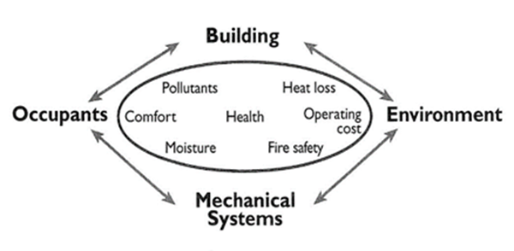

Where Energy Dollars Go
The following breakdown shows where most energy dollars are spent. By far, the largest amount is spent on heating, of both your home and water. Therefore, in developing a priority of actions within your community, you may want to focus initial efforts on improving air sealing, increasing insulation, and upgrading to better heating systems (e.g., installing efficient wood/electric furnaces that capitalize on using wood with the benefit of having backup heat when residents are not home).

Home Energy Maintenance Checklist

Heating
- Caulk and weather-strip doors and windows.
- Caulk and seal leaks where plumbing, ducting, or electrical wiring penetrates through exterior walls, floors, and ceilings.
- Use an inexpensive door sweep to reduce air leakage under exterior doors.
- Seal small holes around water pipes and stuff insulation into larger holes around plumbing fixtures.
- Use foam gaskets that fit behind cover plates to reduce heat loss around light switches and electrical outlets.
- Seal all joints in sheet metal ducts in a forced air furnace with mastic or other appropriate tape.
- Insulate ducts passing through unheated spaces.
- Install insulating gaskets behind electrical outlets and switch plates on exterior walls.
- Upgrade ceiling insulation to R-40 (higher R values mean greater insulation levels and thus more energy savings).
- Insulate exterior heated basement walls to at least R-20.
- Insulate floors over unheated areas to R-20.
- Install storm windows over single pane windows or use plastic film window kits.
- Replace an aging furnace with an efficient model, preferably one with an Energy Star® label.
- Replace single pane windows with energy efficient double pane windows mounted in non-conducting window frames.
- Install temperature controls on all space heat appliances.

Hot Water
- Repair leaky faucets.
- Add an insulating wrap to an older water heater; for a new water heater check your manual to see if this is recommended.
- Install high efficiency low-flow showerheads.
- Replace your water heater, when needed, with an efficient Energy Star® model.

Appliances
- Choose a refrigerator/freezer with automatic moisture control.
- Purchase Energy Star® appliances.

Lighting
- Install CFL or LED bulbs in the fixtures that receive high use.
- Control outdoor lights with sensors or timers so they stay off during the day.

Maintenance Impacts on Home Comfort and Safety

Make a list of what you expect from a house.
Here’s a start:  - Keep the wet out  - Take moisture out  - Keep the wind out  - Stop drafts in the winter  - Allow gentle breezes in the summer  - Keep dust out  - Keep animals and insects out  - Allow residents to easily come in and out  - Keep the sun out  - Keep the heat in  - Keep us comfortable  Add your own: | - Keep us warm in the winter  - Keep us cool in the summer  - Keep our energy bills low  - Keep the noise out  - Keep the music in  - Give us privacy  - Store our possessions  - To be free from hazards and dangers  - To be aesthetically pleasing  - Low maintenance costs  - Long life

Consider the impact of doing specific maintenance on a home.
Example: A cable is routed from downstairs to an upstairs room along the outside of the house. Holes are drilled in the building envelope to create access for the cable. Penetrations are not sealed.
Negative impacts of doing this maintenance without sealing:
- Keep the wet out  - Take moisture out  - Keep the wind out  - Stop drafts in the winter  - Allow gentle breezes in the summer  - Keep dust out  - Keep animals and insects out  - Allow residents to easily come in and out  - Keep the sun out  - Keep the heat in  - Keep us comfortable | - Keep us warm in the winter  - Keep us cool in the summer  - Keep our energy bills low  - Keep the noise out  - Keep the music in  - Give us privacy  - Store our possessions  - To be free from hazards and dangers  - To be aesthetically pleasing  - Low maintenance costs  - Long life

Consider the impact of not doing specific maintenance on the homes.
Example: A gas furnace is not regularly serviced.
Negative impacts of not doing this maintenance:
- Keep the wet out  - Take moisture out  - Keep the wind out  - Stop drafts in the winter  - Allow gentle breezes in the summer  - Keep dust out  - Keep animals and insects out  - Allow residents to easily come in and out  - Keep the sun out  - Keep the heat in  - Keep us comfortable | - Keep us warm in the winter  - Keep us cool in the summer  - Keep our energy bills low  - Keep the noise out  - Keep the music in  - Give us privacy  - Store our possessions  - To be free from hazards and dangers  - To be aesthetically pleasing  - Low maintenance costs  - Long life

Example: Windows and doors are not properly installed and sealed.
Negative impacts of doing this maintenance improperly:
- Keep the wet out  - Take moisture out  - Keep the wind out  - Stop drafts in the winter  - Allow gentle breezes in the summer  - Keep dust out  - Keep animals and insects out  - Allow residents to easily come in and out  - Keep the sun out  - Keep the heat in  - Keep us comfortable | - Keep us warm in the winter  - Keep us cool in the summer  - Keep our energy bills low  - Keep the noise out  - Keep the music in  - Give us privacy  - Store our possessions  - To be free from hazards and dangers  - To be aesthetically pleasing  - Low maintenance costs  - Long life

New Construction Insulation and Air Seal Checklist*
Insulation /Air Seal Detail | Insulation  Continuity | Air Barrier  Continuity
Interior pony wall at a basement
Rim joist
Interior wall penetrating an exterior wall
Insulated floor above garage
Electrical penetration
Electric panel set into an exterior wall
Duct penetrating at a wall
Wall behind shower/tub
Wall behind fireplace
Staircase walls
Plumbing stack in an exterior wall
Wall adjoining porch roof
Door frame connection to a wall
Attic knee walls
Skylight shaft walls
Attic access panel / stair
Dropped ceiling/soffit
Recessed lighting fixtures
Cantilevered/floors over unheated spaces
Steel/Masonry chimney penetrating an attic
Part wall at an exterior wall and attic
Plumbing stack at an attic penetration
Tapered insulation at the attic edge
Slab-edge Insulation
Large beam set into a wall
Attic/garage framing running alongside an exterior insulated wall
Window and door and skylight rough opening
Concrete in ICF penetrations
Joints in air barrier
*Explanation and graphics of air sealing details can be found in the Illustrated Guide to Energy Efficiency Requirements for Houses in BC included on the USB provided. Please refer to your correct region for more information.

Building Construction Standard Comparison
 | Current BC Building Code | Energuide 80 | R-2000 | Energy Star®
Requirements | - Insulation, space and water heating equipment designed and installed in accordance with 9.36 of the BC Building Code | - Use energy efficient windows, heat recovery ventilation or improved insulation to meet energy target  - High efficiency space and water heating appliances | - Heat recovery ventilation required  - Mandatory air tightness levels  - Increased insulation of building enclosure to meet Energuide 80 performance level | - Use Energy Star® windows  - Use Energy Star® appliances  - Heat recovery ventilation required  - Increased insulation of building enclosure above code minimum  - Mandatory air tightness levels  - High efficiency space and water heating appliances
Costs | - Standard | - Additional $8,000 - $12,000 (or higher) per house | - Additional $8000 - $12,000 (or higher) per house | - Additional $10,000 - $15,000 (or higher) per house
Potential Energy Savings | - Baseline | - Varies | - 20% | - 20%
Benefits | - Cost effective house and construction cost | - Reduced operating costs  - Improved indoor air quality  - Reduced noise  - Improved humidity control | - Reduced operating costs  - Improved indoor air quality  - Reduced noise  - Improved humidity control  - Built by certified R2000 contractor | - Reduced operating costs  - Improved indoor air quality  - Reduced noise  - Improved humidity control
Drawbacks | - Unquantified higher operating costs reflecting lower air sealing and other construction standards | - Higher initial cost  - Investment in additional training for maintenance persons on new components | - Higher initial cost  - Investment in additional training for maintenance persons on new components | - Higher initial cost  - Investment in additional training for maintenance persons for new components
The BC Building Code has recently adopted new requirements for energy efficiency of new homes. These requirements and the building code reference are summarized below.
Requirement | BC Building Code Reference*
Insulate ceilings, walls, and floors | Table 9.36.2.6.A and Table 9.36.2.6.B. for the correct climate zone.
Use energy efficient windows, door and skylights | Table 9.36.2.7 A, B and C for the correct climate zone.
Insulate foundations and assemblies in contact with the ground | Table 9.36.2.8.A or B for the correct climate zone.
Ducts located in the attic or garage are sealed and insulated. | 9.36.3.2.
Dampers are installed at air inlets and exhausts. | 9.36.3.3.
Heating equipment is located within the house | 9.36.3.5.
Temperature controls are installed on heating and cooling equipment. | 9.36.3.6.
Space heating and domestic hot water appliance meet efficiency requirements. | Tables 9.36.3.10. and 9.36.4.2.
Service water heating pipes are insulated at the inlet and outlet of storage tanks. | 9.36.4.4.
Water heaters have temperature controls. | 9.36.4.5.
The air barrier details, materials and locations have been identified. | 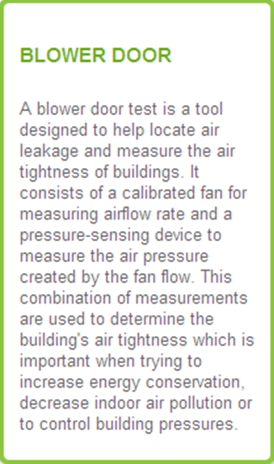  9.36.2.9., 9.36.2.10
*A copy of the Illustrated Guide to Energy Efficiency Requirements
for Houses in BC (a supplement to the BC Building Code Standards)
is included on the USB provided. Please refer to your correct region
for more information.

Did you know?

Policy Development
A holistic Housing Policy, including energy efficiency requirements, represents the ‘tip of the iceberg’ in terms of the larger management and housing structure in a community. The following pyramid highlights a logical series of steps and considerations that can be followed to build a solid foundation for policy development.
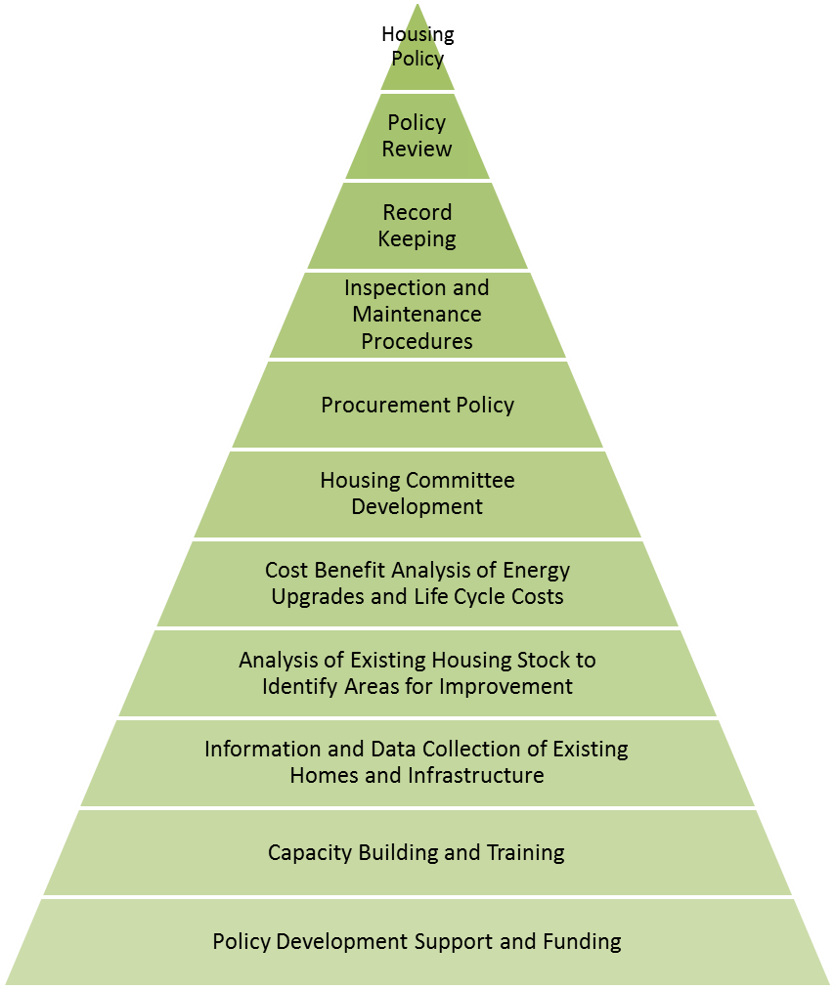
Policy development process

