SWC Grant Program Guide and Application Form

Program overview

Phosphorus (P) is a key nutrient in land and aquatic ecosystems. Many forms of life need P to grow and reproduce. Therefore, it’s important for supporting a healthy ecosystem. But, excessive nutrients in an aquatic ecosystem can reduce water clarity, create odours, and reduce the quality of water for drinking and recreation.

New research by the University of British Columbia – Okanagan has determined that a significant portion of phosphorus in Shuswap River and Salmon River is coming from seasonal streams, ditches, groundwater, and surface run-off in the settled valley bottoms. Although the research found that P also comes from the large tributaries and the upper reaches of the watershed, the highest concentrations come from the valley bottoms where there is urban and agricultural development, in regions of the watershed known as incremental flow sub-watersheds (IFSWs). Please see the publication, Understanding Nutrients and Water Quality in the Shuswap River and Salmon River, available at www.shuswapwater.ca.

In an effort to protect water quality for the future, the Shuswap Watershed Council (SWC) is providing financial support to agriculturalists and landowners for projects that divert or mitigate the flow of phosphorus-rich waters and effluents so that less P ends up in the rivers, and ultimately in Shuswap and Mara Lakes. Management actions to reduce P inputs will be most effective if they are carried out in the IFSWs, or the settled valley bottoms (see maps in Appendix 1).

Up to $85,000 is available in 2021, subject to SWC approval, through this granting program. The number of grants awarded and the amount of each grant awarded will be dependent on the merit of the applications received (see application form in Appendix 2). SWC will fund a maximum of 50% of the project costs, the remainder must come from other sources, whether cash or in-kind labour, equipment or material (see standard rates for in-kind contributions in Appendix 3).

Eligibility

Eligible applicants include the following:
- Individual landowners and hobby farms
- Agri-businesses
- First Nations governments
- Non-profit organizations

Ineligible applicants include the following:
- Local governments
- Provincial and federal government agencies
- Consultants

Eligible projects must:
- Be located in the Shuswap Watershed (see maps in Appendix 1)
- Demonstrate improvements to water quality by reducing the flow of P-rich run-off or effluent from land to surface waters in the Shuswap Watershed
- Ideally be completed within one year of grant award, but no longer than 18 months from the time of the award
- Leverage at least 50% of funds and/or in-kind contributions from other sources

Eligible activities include:
- Projects that reduce phosphorus inputs to surface waters (creeks, rivers, lakes) in the Shuswap Watershed

Examples of suitable projects may include but aren’t limited to wetland development or restoration, riparian improvements, cover cropping, improved irrigation practices, improved livestock practices, improved manure management, and improved effluent storage to name a few.

Ineligible activities include:
- Studies and research
- Planning
- Education and outreach
- Any activities ordered by compliance and enforcement action

Recommendations to Applicants

Applicants are encouraged to consider the following when preparing their application:
- Other sources of funding may include their own cash, or other sources of funding (e.g., Environmental Farm Plan, grant program funds from other governments, foundations or the private sector)
- Applicants may want to connect with someone familiar with other funding programs and implementing projects to coordinate their application. This could be someone in a livestock or agricultural industry association, or someone involved in restoration works.
- Consider submitting a group application with neighbouring properties, in particular for riparian restoration projects. This will increase the project scale and scope, which is part of the evaluation criteria.
- Water quality baseline monitoring before and after project implementation is encouraged, but not required

How to apply for grant funding

Potential applicants are encouraged to contact SWC program managers to discuss their project concept, no later than April 16th, 2021.

Complete the application form in Appendix 2 beginning on Page 8 of this Guide, include a map of your proposed project area, and submit by email (preferred) or regular mail to:

Mike Simpson
SWC Program Manager
c/o Fraser Basin Council
200A-1383 McGill Road
Kamloops, BC V2C 6K7
msimpson@fraserbasin.bc.ca

Completed applications must be received by 4PM Pacific Daylight Time on April 30th, 2021.

Evaluation Process

Applications will be evaluated and scored subjectively by the SWC based on the following:
- Technical merit of what is proposed and likelihood to achieve outcomes (25%)
  - Note that water quality baseline monitoring before and after project implementation is encouraged, but not required
- Location and proximity of the project to a water body (creek, river, or lake) (25%)
  - Note that priority may be given to projects proposed in the IFSW of the Salmon River or Shuswap River watersheds (see maps in Appendix 1)
- Scale and scope of project (20%)
- Leveraging of other funds or in-kind donation of labour, equipment or material beyond the minimum of 50% (10%)
- New applicants, not previous recipients (10%)
- Clarity and completeness of proposal (10%)

Applications will be anonymized to the fullest extent possible to encourage objectivity during the evaluation process.

Proposals will be evaluated in May 2021. Successful applicants will be contacted in mid-June.

The SWC reserves the right to refuse any or all applications received. SWC reserves the right in its sole discretion at any time, and from time to time and for whatever reason, to by addendum, modify, amend, cancel or otherwise change this granting program at any time. This granting program should not be construed as an agreement to purchase goods or services. SWC is not bound to award funds to any proponent. SWC will not be obligated in any manner to any potential proponent whatsoever until an agreement has been entered into.

Terms and Payments of Grants

The following are the terms and payments of the grants:
- Upon successful award of a grant, an agreement shall be signed by SWC and the grant recipient
- Up to 50% of the funds may be advanced upon signing of the grant agreement based on demonstrated need
- Remainder of the funds will be advanced upon completion of the project and providing receipts for eligible expenses
- Funds granted are not transferrable to other projects without the written approval of SWC program managers
- Quarterly reporting by grant recipient on progress of the project in writing
- SWC shall be acknowledged in any publications, announcements or signage
- SWC will be permitted to publish information about grant recipients, project details, and photos. In addition, the grant recipients agree to work with SWC to conduct an educational field tour or short video demonstration.
- Grant recipients must comply with all applicable laws and seek the necessary permits and/or authorizations necessary to undertake the project.

About the Shuswap Watershed Council

The SWC was established in 2014 as a watershed-based partnership to enhance water quality and safe recreation in the Shuswap. There are 18 members that represent three regional districts, two municipalities, the Secwepemc Nation, two provincial government agencies and Shuswap communities. The SWC is a collaborative, non-regulatory group. It works alongside organizations that have regulatory roles in managing the Shuswap watershed, complimenting their work and carefully avoiding duplication.

Our Vision
Enhanced water quality that supports human and ecosystem health and the local economy in the Shuswap watershed.

Our Objectives
The SWC’s objectives are to maintain and enhance water quality in the Shuswap watershed through collaboration with water quality monitors; to coordinate and report on water quality in the Shuswap; to inform residents and visitors about water quality in the Shuswap, and advocate for good practices to prevent water quality degradation; and to encourage safe behaviour by recreationists on and near water.

Appendix 1 – Maps

Shuswap Watershed
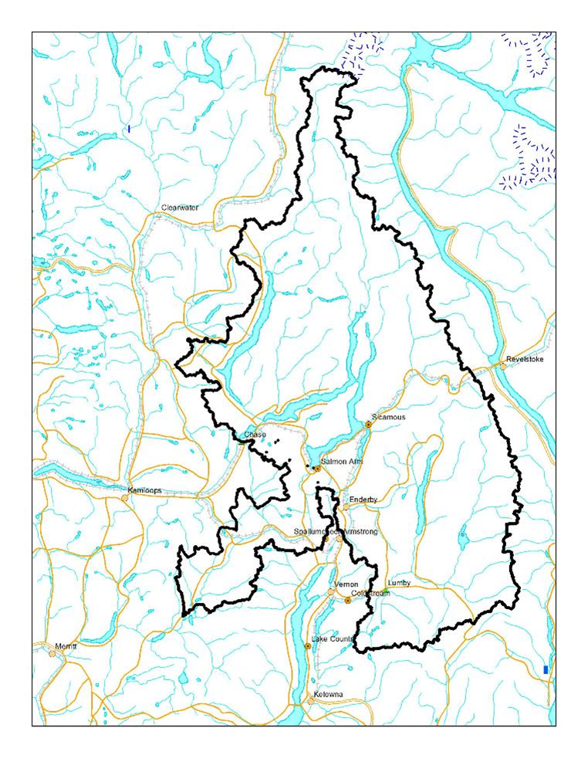

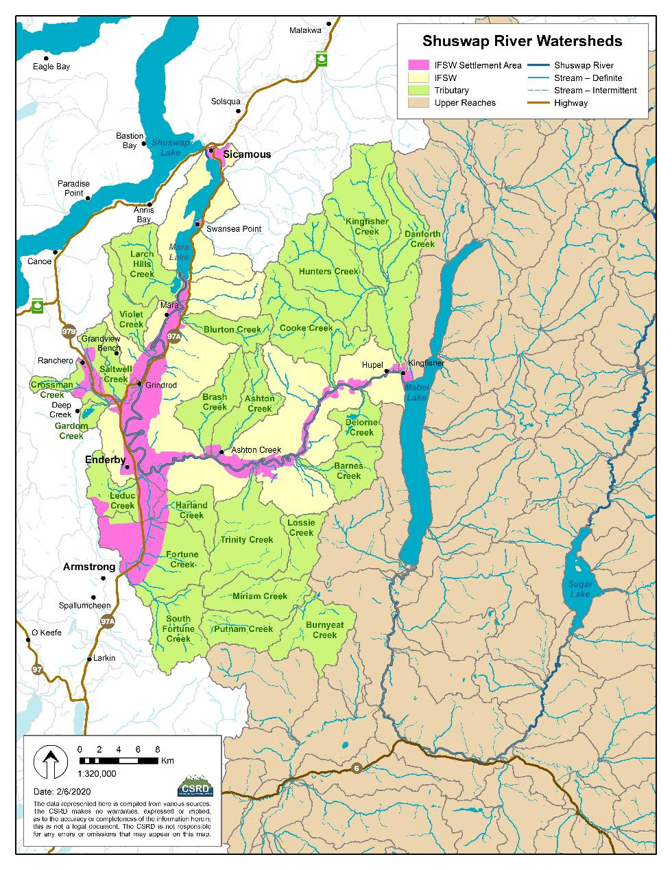
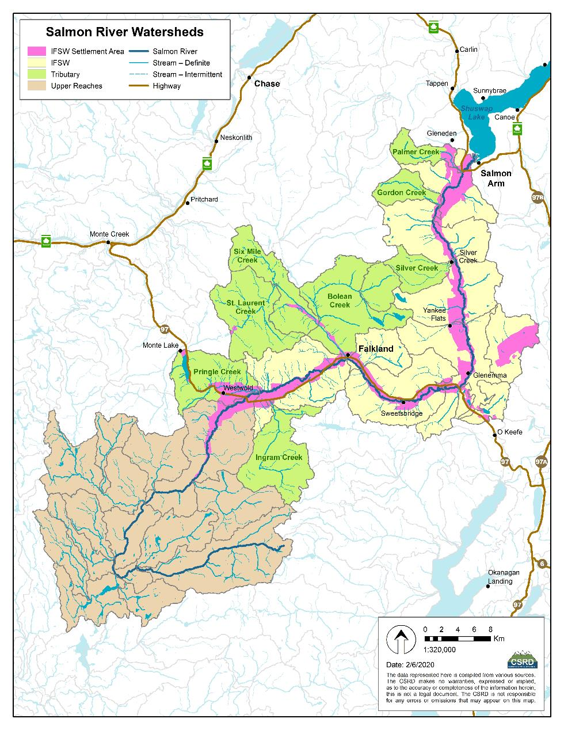

Appendix 2 - Application Form
Enter your answers in the boxes provided (the boxes will get bigger as you fill them out). Please try to keep your completed application to six pages or less.

Section 1 - Applicant information

Applicant name (organization, if applicable):

Applicant contact name:

Applicant title (if applicable):

Applicant mailing address:

Applicant email address:

Section 2 - Project information

Title of the project:

Location of the project (physical address, latitude/longitude, UTM coordinates) (include a map in any format – scan of a sketch map, a google earth file, pdf map):

Project description (describe what you intend to do, including methods and timelines):

Project goals (what is the goal you are trying to achieve):

Project outcomes or deliverables (what will be the result at the end of the project):

How the project maintains or enhances water quality (specifically include how the project will divert or mitigate the flow of P-rich effluent or run-off to a nearby creek, river, or lake)

Project longevity (how will you ensure that the benefits of the project last into the future):

What permits or authorizations might your proposed project require you to have before work can begin?

Section 3 - Project budget:

Fill out the following tables with as much information as possible.

Project Revenue: | SWC grant request ($) | Other cash ($) | In-kind* ($) | Source of other cash | Other cash secured? (Yes/No) | Source of in-kind | Value ($) of in-kind  (i.e., rate or price and number of hours or units)
Example: | 20,000 | 15,000 | 4,800 | ABC Foundation | Yes | Privately owned heavy equipment | $120/hr x 40 hrs
 |  |  | 1258.80 |  |  | T-rail Fence posts | $10.49 x 120
(Your application starts here)
Subtotals
Totals

Project expenses | SWC grant request ($) | Other cash ($) | In-kind* ($) | SWC will fund a maximum of 50% of the project costs, the remainder must come from other sources, whether cash or in-kind labour, equipment or material
Labour
Material
Equipment
Travel
Other (specify in cells below)
Subtotals
Totals

*In kind can include labour, equipment and/or materials provided by the applicant. See Appendix 3 for standard rates to use in your calculations.

Additional notes about project revenue and/or project expenses (optional):

Section 4 - Other information

Provide any other information about the project that you want to be evaluated by the Shuswap Watershed Council (e.g., collaboration with other parties, building on past projects, etc.):

Acknowledgement

By submitting an application, applicants agree to be bound by the terms and conditions of this granting program. If a grant is issued, the successful applicant will be bound by and comply with the terms and conditions contained in the agreement which will constitute the full and complete agreement between the parties.

Appendix 3 – Standard Rates for In-kind Contributions

In-kind contributions are labour, materials and supplies, or use of equipment that the applicant owns and provides. When completing the application, please use the following standardized rates. Applications that do not use standardized rates will have calculations adjusted accordingly.

Labour – all found including employer costs, payroll loading
- $25/hour

Material and supplies – including but not limited to fence posts, supplies
- At cost or fair market value
- Receipts or confirmation of value may be sought

Equipment – all found including operator cost, fuel, insurance
- Excavator - $120/hour
- Tractor with loader, or loader - $100/hour
- Dozer - $80/hour
- Backhoe - $80/hour
- Skid-steer - $85/hour
- Flat deck trailer - $50/hour
- Chainsaw - $30/hour

